Photo by Karen Will Rogers

***Singer-songwriter David G Smith is a major find.***

***--Robert K. Oermann/Music Row***

***David is a brilliant singer/songwriter/guitarist. [His] originals speak for those who have no voice.***

***--Nashville Blue & Roots Alliance***

***[Smith] comes across with the same weathered resolve that best exemplifies fellow travelers like Kris Kristofferson and Townes Van Zandt.***

***--Lee Zimmerman/No Depression***

***NEW RELEASE - Who Cares***

**Internationally acclaimed singer-songwriter David G Smith is an acoustic solo performer with a lyric intensive style featuring music and a voice that range from dirt-funk to intimate. Think James Taylor meets Townes Van Zandt. His music is featured on TNT, Lifetime Network, Travel Channel and he is a regular performer at the Bluebird Café Nashville. His last 3 (of 7) albums have been accepted for Grammy consideration. David, his voice and his songs are authentic. *“Like Mary Gauthier and Sam Baker, Smith cuts though….to find essential phrases and words to represent the ache of living”.* (Fervor Coulee)**

• Feat in American Songwriter Jan 2020.

• Two nationwide #1 singles on Roots Music Report’s Alt

Folk Chart including 2019’s “Mi Familia”.

• 2008 International Song Competition 1st Place Winner.

•Last 3 albums #1 on RMR’s Top 50 Iowa Album Chart.

• “Angels Flew” is listed on the 9/11 Memorial Museum

Artists Registry.

• “Doesn’t Take Much Light” was featured on Scouting

Magazine’s Blog + performed by David to 5000 Eagle

Scouts at Michigan State University arena.

• Has shared the stage with Justin Townes Earle,

Ramblin’ Jack Elliot, Kelly Willis + Bruce Robison,

5-time WC Handy Award winner Rory Block, Griffin

House, Buddy Mondlock, Kevin Gordon, Jelly Roll

Johnson, Dave Moore, + Chuck Pyle.

• David raises money + awareness for St. Jude Children's

Hospital, Boys Town, and several other worthy causes.

***Contact David at***

***Phone 615.483.1781***

***Email*** [**davidgsmithmusic@yahoo.com**](mailto:davidgsmithmusic@yahoo.com)

***Website*** [***heydavemusic.com***](https://heydavemusic.com/)

***For everything else google:***

***David G Smith Music***

Photo by Mary Lou Reiter-Kean

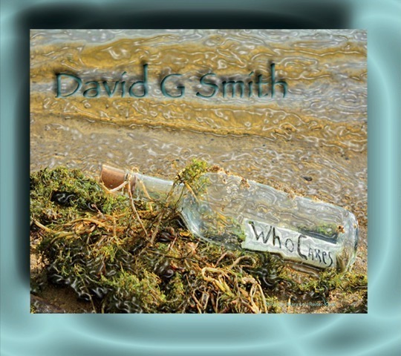

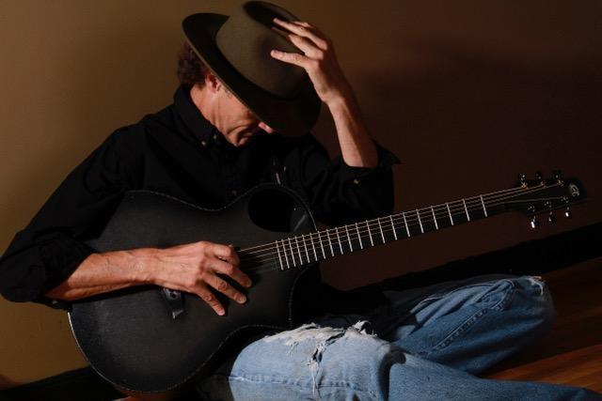

*David G Smith’s* Music available @

• This Show! Ask Me! Cash/Credit

• www.davidgsmithmusic.com

NewLogoCropped.pdf